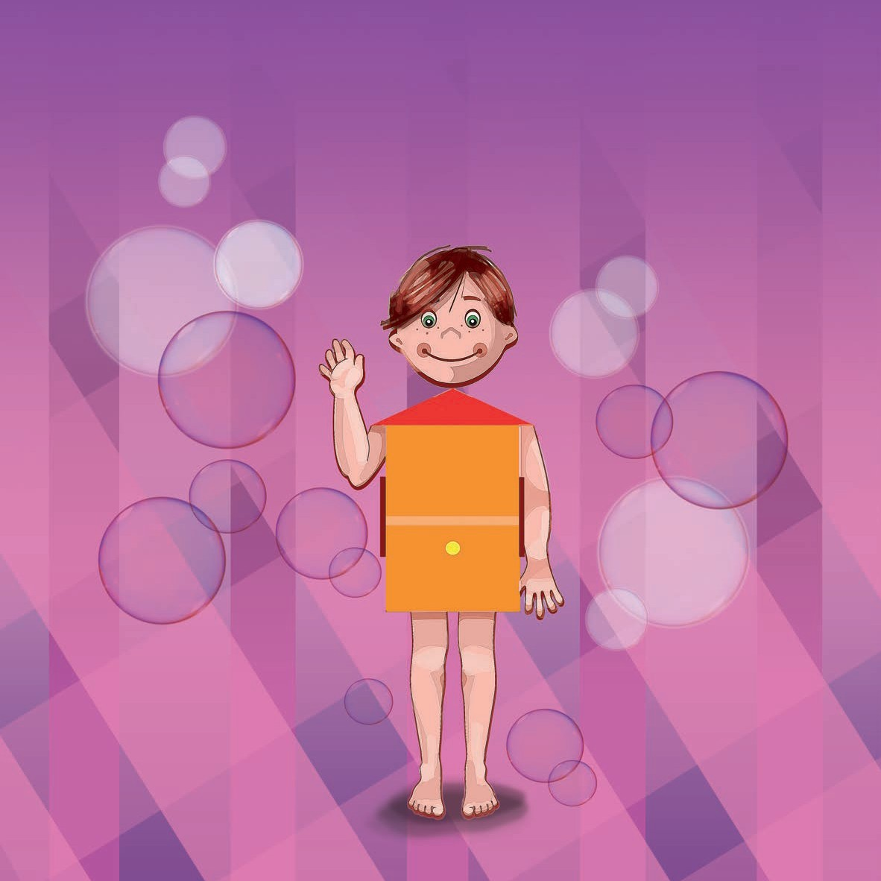
Gioberto
and his House
The Pilates Method
a story for children and preadolescents

by Beatrice Marrocol
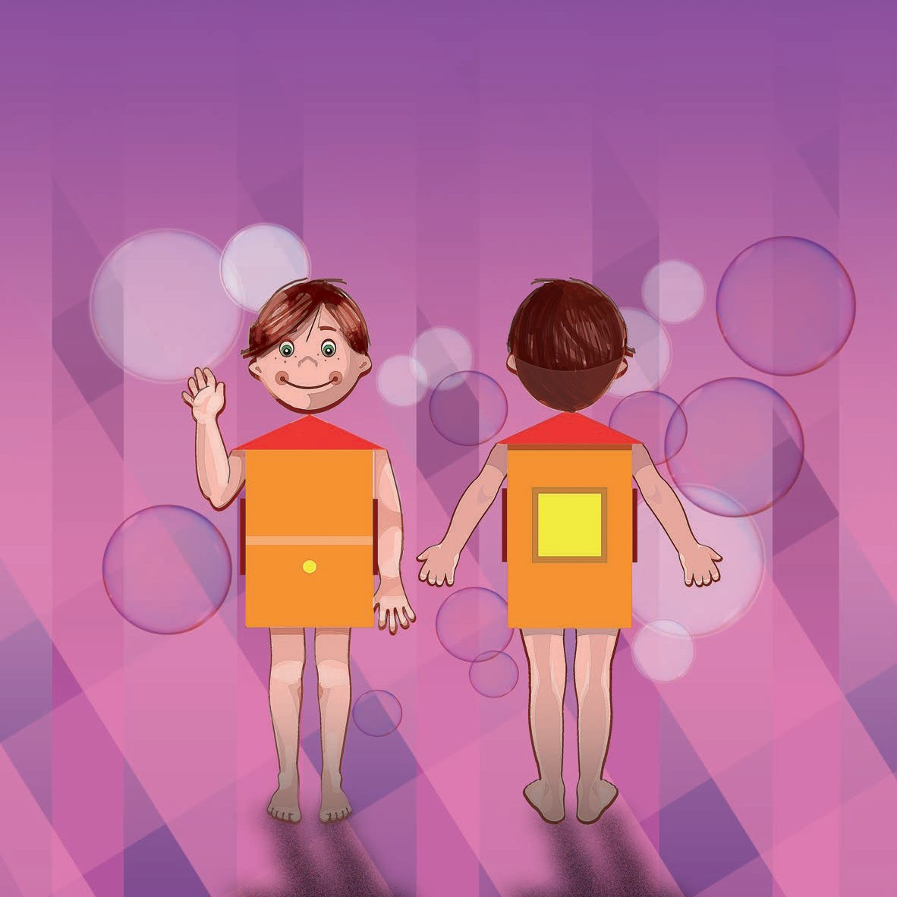
nce upon a time, there was a boy by the name of Gioberto. He was a very special child because he had a body shaped like a house, a magic house that gave him Super Powers… This house was on two floors. There were no doors, just windows:
O
three large ones upstairs (two at the sides and one at the back of the house); and a tiny one on the lower floor, right on the front. The walls could expand and contract, and the floors could bend downwards and upwards.
Now, sit back comfortably, while I tell you how Gioberto used his
Super Powers that were made out of light and sparkling soap bubbles ...

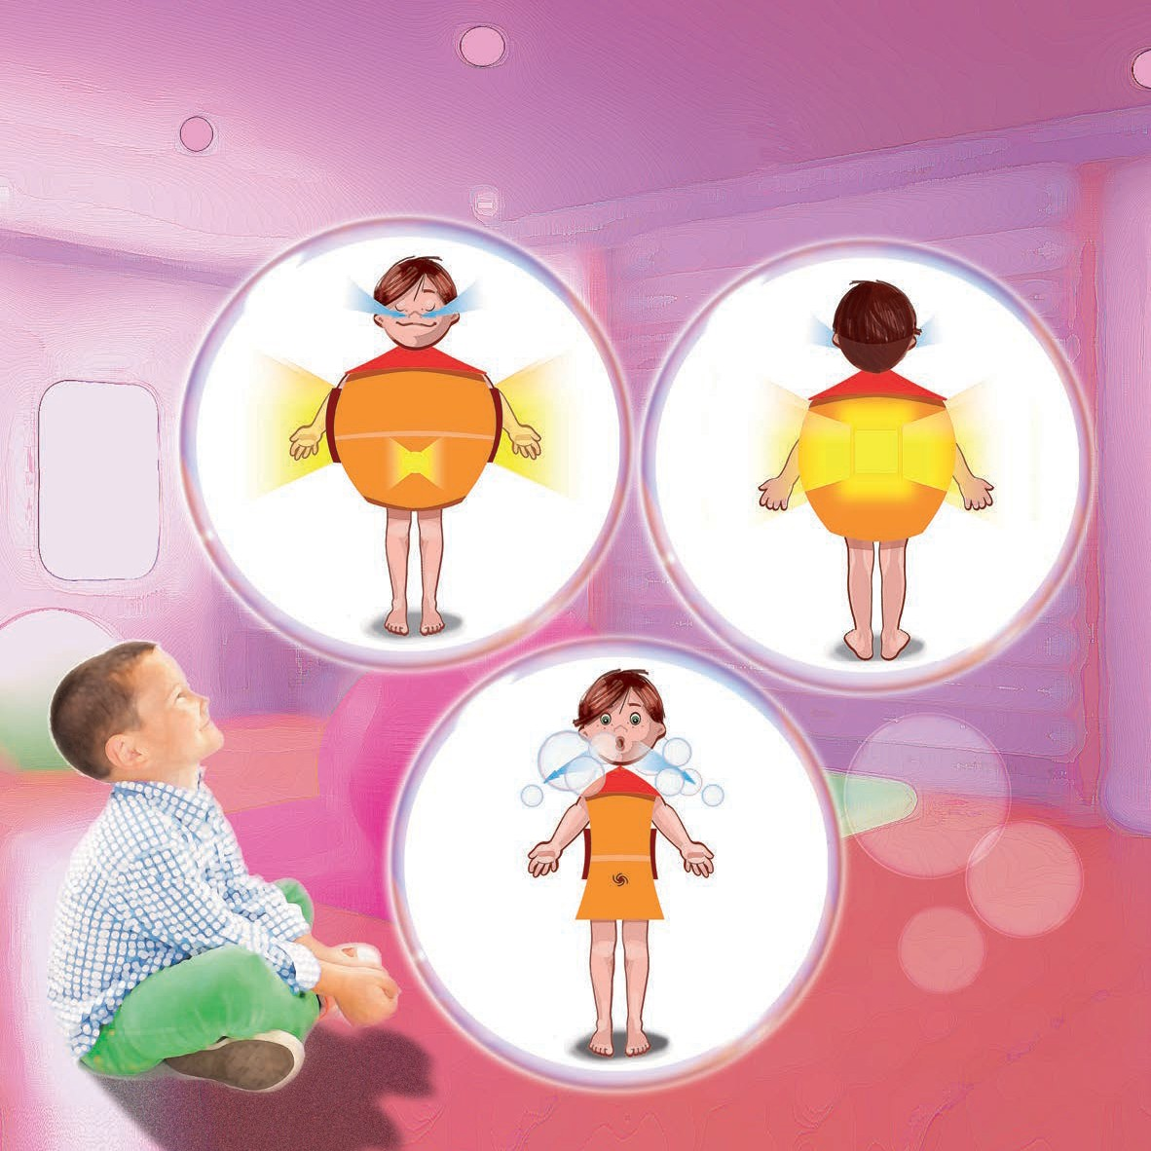
reathe out. When you inhale (take air in with your nose), a light turns on inside you that illuminates your entire body, and when you exhale all that light comes out of your mouth and turns into soap bubbles. Go back to breathing and imagine you
B
want to illuminate just the top floor of the house, where the large windows are. The light is so intense that it stretches the walls and comes out of the windows. Exhaling, let the light come out of your mouth in the form of soap bubbles. Repeat as often as you like, try and try again

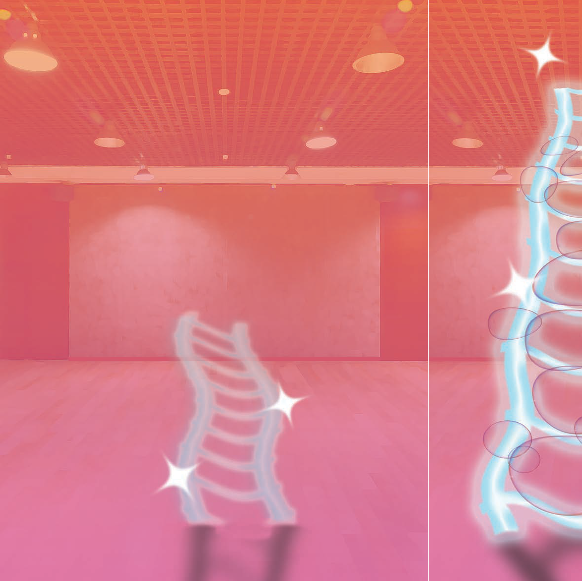
n inhaling the lower floor of the house will light up, the part with one tiny window on the front: your navel !!! The light stretches the walls and flows out from the small "navel" window and
O
then, on exhaling, the air entrapped in the large and small soap bubbles will sparkle… MAGIC MAGIC
THE FLOOR BENDS IN AN UPWARDS DIRECTION AND A LONG LADDER POPS OUT
Well, it is precisely at that moment that Gioberto began to feel good and ready to take advantage of his Super Powers.
Obviously it is a magic ladder, made of light and soap bubbles that fit together between the rungs, and you can only go up and down with your mind and one step at a time.

